Connecting Crumbles

Draw or drag the crocodile clips to connect your Crumble controller to the battery box and the Sparkle.

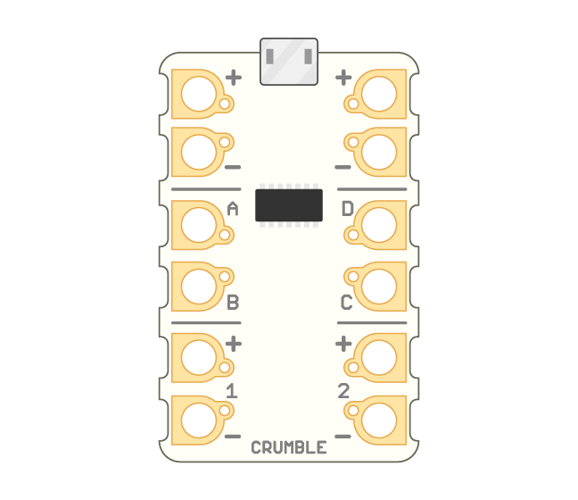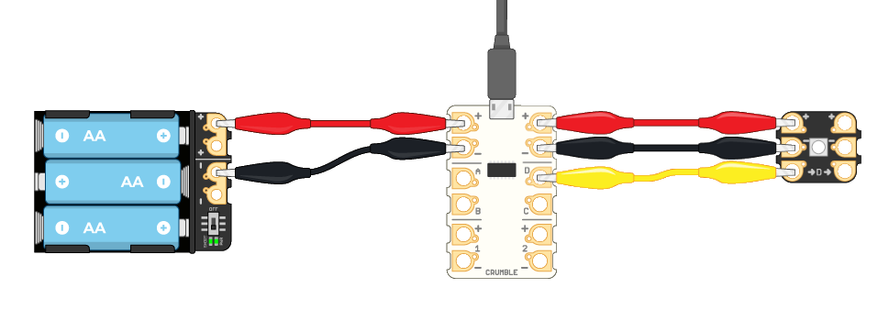

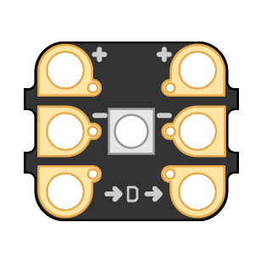

Sparkle

Battery box

Crumble controller

This resource is available online at [ncce.io/pg5a-1-a1-w](http://ncce.io/pg5a-1-a1-w). Resources are updated regularly — please check that you are using the latest version.

This resource is licensed under the Open Government Licence, version 3. For more information on this licence, see [ncce.io/ogl](http://ncce.io/ogl).