Project design

Sprite | Describe what your sprite will do | Event blocks (circle one for each sprite) | Motion blocks (choose at least two for each sprite)
Sprite 1  __________ | Move / Turn / Go to | 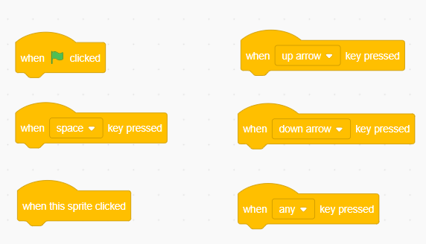 | 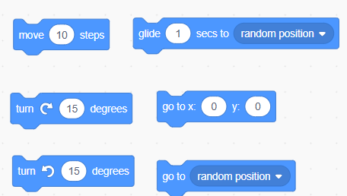
Sprite 2  ___________ | Move / Turn / Go to
Sprite 3  __________ | Move / Turn / Go to

